SMART WATER MANAGEMENT

# ABSTRACT:

The effective management of water resources is an imperative global challenge in the face of growing populations, climate change, and increasing urbanization. Smart Water Management (SWM) has emerged as a promising solution to address these challenges by integrating advanced technologies, data analytics, and innovative strategies. This abstract provides a concise overview of the key components and benefits of SWM.

Figure 1:SMART WATER MANAGEMENT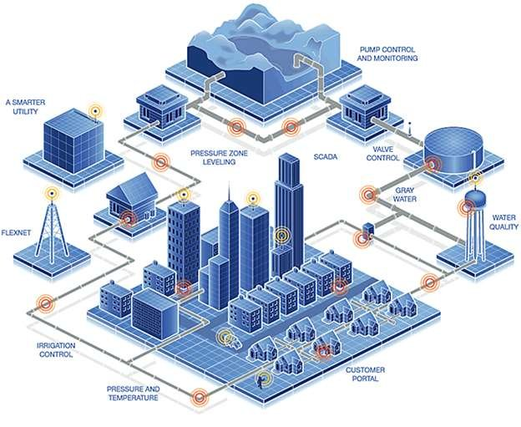

# OBJECTIVES:

## 1.Water Conservation:

* Reduce water wastage and promote efficient water use.
* Decrease water consumption in residential, industrial, and agricultural sectors.

## 2. Leak Detection and Prevention:

* Implement systems to detect and respond to leaks promptly.
* Minimize water losses in distribution networks.

## 3.Real-time Monitoring:

* Establish a comprehensive system for real-time monitoring of water quality and quantity.
* Ensure timely response to deviations and anomalies in water systems.

## 4.Data Analytics and Decision Support:

* Utilize data analytics and modeling to make informed decisions.
* Enhance predictive capabilities for water resource management.

## 5.Demand Management:

* Implement demand management strategies to balance supply and demand.
* Encourage water-efficient practices among consumers.

## 6.Water Quality Management:

* Maintain high water quality standards.
* Monitor and address issues related to contamination and pollution.

## 7.Infrastructure Optimization:

* Upgrade and maintain water distribution and treatment infrastructure.
* Incorporate smart technologies to improve the efficiency of water delivery.

## 8.Smart Metering:

* Deploy smart water meters for accurate consumption measurement.
* Enable remote monitoring and real-time billing.

## 9.Customer Engagement:

* Educate and engage the community in water conservation efforts.
* Provide feedback to consumers about their water usage.

## 10.Emergency Response and Disaster Preparedness:

* Develop contingency plans for droughts, floods, and other water-related disasters.
* Establish efficient response mechanisms in case of emergencies.

# COMPONENTS:

## 1.IoT Sensors:

Internet of Things (IoT) sensors can be deployed in water distribution systems, water treatment plants, and other relevant locations to monitor parameters such as water flow, pressure, quality, and temperature in real-time.

## 2.Data Collection and Monitoring:

Data from IoT sensors and other sources are collected and monitored continuously. This data can provide insights into consumption patterns and potential issues in the water supply system.

## 3. Data Analytics:

Advanced analytics and machine learning algorithms can be used to process and analyze the data, identifying trends, anomalies, and opportunities for optimization.

## 4.Remote Control and Automation:

Smart water management systems can include automation capabilities that allow for remote control of water distribution, valve adjustments, and system operations to optimize water use in real-time.

## 5.Leak Detection:

Automated leak detection systems can pinpoint the location of leaks or abnormal water consumption patterns, helping to reduce water losses.

## 6.Consumer Engagement:

Consumers can be provided with real-time information about their water usage through mobile apps and web interfaces, encouraging responsible water consumption.

## 7.Water Quality Monitoring:

Continuous monitoring of water quality ensures that water is safe for consumption and that treatment processes are functioning properly.

## 8. Demand Forecasting:

Advanced forecasting models can predict future water demand patterns, allowing utilities to prepare for changes in consumption and optimize water distribution.

## 9.Asset Management:

Smart water management systems can assist in managing and maintaining water infrastructure assets such as pipes, pumps, and tanks, ensuring their optimal performance.

## 10.Water Conservation Measures:

Utilities can use the data and insights obtained from the system to implement water conservation measures and incentives for consumers and industries.

# WATER CONSUMPTION SENSOR TYPES:

# 1.Flow Meters:

* Mechanical Flow Meters:
  + - These meters use mechanical components like rotors or turbines to measure water flow rates.
* Ultrasonic Flow Meters:
  + - Ultrasonic sensors use sound waves to determine the velocity of water, which can then be used to calculate flow rates.
* Magnetic Flow Meters:
  + - These meters use the conductive properties of water to measure flow by inducing a magnetic field in the fluid.
* Vortex Flow Meters:
  + - Vortex shedding technology measures flow by detecting the frequency of vortices created as the fluid passes an obstruction.

# PIN DIAGRAM:

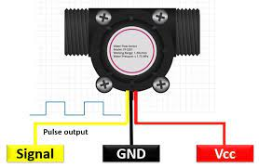

# PIN DIAGRAM CONFIGURATION:

1. Power Supply (Vcc):

This pin provides the power supply voltage required for the flow meter to operate. The voltage level may vary depending on the specific flow meter's requirements.

1. Ground (GND):

This pin connects to the ground reference, completing the electrical circuit.

1. Signal Output (OUT):

The flow meter may have an output pin that provides an analog or digital signal representing the flow rate. The type of signal (analog voltage, current, pulse, or digital communication protocol) can vary.

1. Communication (COM):

Some flow meters, especially digital ones, may have communication pins for connecting to a data logger, PLC, or control system. Common communication interfaces include RS-485, Modbus, or HART.

1. Sensor Pins:

Depending on the type of flow meter, there may be additional pins related to the specific sensor technology used in the meter. For example, ultrasonic flow meters may have transmitter and receiver pins.

1. Configuration Pins:

Some flow meters may have pins for configuring various settings, such as calibration or units of measurement. These pins might be labeled differently depending on the manufacturer.

1. Grounding Shield (SHIELD):

If your flow meter has a shield or grounding connection to reduce electromagnetic interference, it will have a dedicated pin for this purpose.

1. Alarm Outputs (ALARM):

Some flow meters may provide alarm outputs to indicate when flow rates exceed or fall below predefined thresholds.

# 2.Pressure Sensors:

Pressure sensors are used to monitor water pressure within a system, which can indirectly provide information about water consumption.

# PIN DIAGRAM:

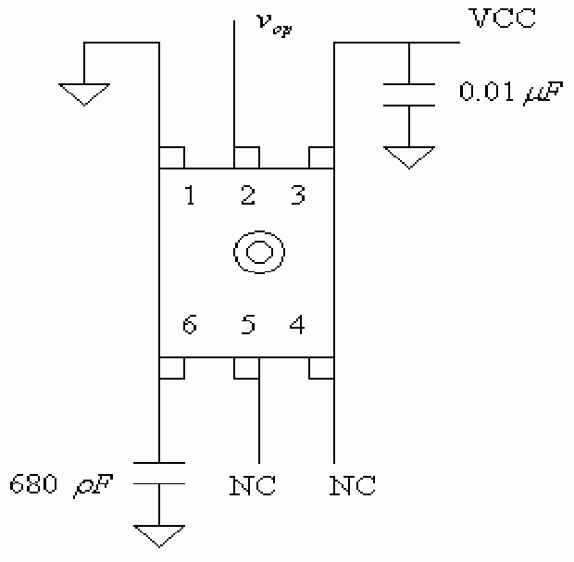

# PIN DIAGRAM CONFIGURATION:

1. VCC (or +Vs):

This is the supply voltage pin. You connect it to your power supply to provide the necessary voltage for the sensor to operate. The voltage level may vary depending on the sensor's specifications, but it is usually in the range of 5V to 12V.

1. GND (or 0V):

This is the ground or common reference point. Connect it to the ground of your power supply to establish a common ground reference.

1. Vout (or OUT):

This is the output pin of the sensor. It provides an analog voltage signal that varies based on the pressure detected by the sensor. You will connect this pin to an analog input on a microcontroller, data acquisition system, or another device to read the pressure value.

# 3.Smart Water Meters:

These meters are equipped with digital technology and communication capabilities, allowing for remote monitoring and data collection. They can be used in both residential and commercial settings.

# PIN DIAGRAM:

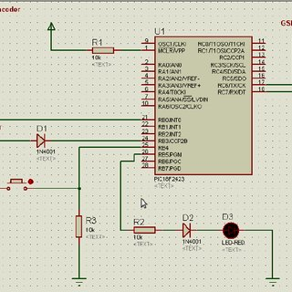

Figure 2:SMART WATER METER

# PIN DUAGRAM CONFIGURATION:

1. **Water Flow Sensor**:

The water flow sensor is a critical part of the smart water meter. It typically has a pin configuration like:

* + VCC (Power supply voltage)
  + GND (Ground)
  + Signal output (Pulse signal indicating water flow)

1. **Microcontroller or Processing Unit**:

The smart water meter usually has a microcontroller or processing unit to handle data processing and communication. The pins for this unit may include:

* + VCC (Power supply voltage)
  + GND (Ground)
  + Data input/output pins (for communication)
  + Serial communication pins (like UART, SPI, or I2C, if applicable)
  + Power-related pins (such as power enable or reset)

1. **Communication Module**:

Smart water meters often have communication modules to transmit data to a central system. Common communication methods include:

* + UART/TTL pins for serial communication with the microcontroller
  + Wired communication (e.g., Ethernet, RS-485, or RS-232 pins)
  + Wireless communication (e.g., Wi-Fi, cellular, LoRa, or Zigbee pins)

1. **Power Supply**:

The power supply pins usually consist of VCC (for supplying power) and GND (ground).

1. **Display (Optional)**:

If the smart water meter has a display, it may have pins for power, data input, and backlight control.

1. **Additional Sensors (e.g., Temperature, Pressure)**:

Some smart water meters may incorporate additional sensors for measuring temperature, pressure, or other parameters. These sensors will have their own pin configuration.

1. **Antenna (for Wireless Communication)**:

If the meter uses wireless communication, it will have an antenna or antenna connector.

1. **Battery or Power Supply Connector**:

Some smart water meters can be battery-powered. In such cases, there will be pins for connecting or replacing the batteries.

# 4.Ultrasonic Level Sensors:

Ultrasonic level sensors are used to monitor the level of water in tanks, reservoirs, and wells. They can provide data on water consumption over time by tracking changes in water levels.

# PIN DIAGRAM:

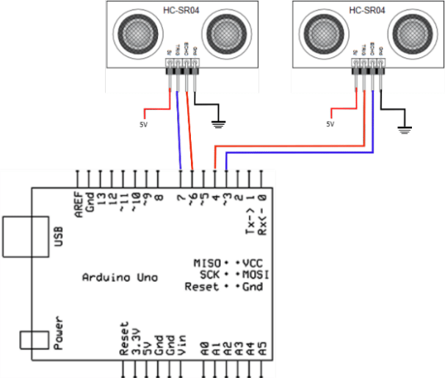

# PIN DIAGRAM CONFIGURATION:

1. **Vcc (Voltage Supply):**

This is the power supply pin. You typically provide a voltage source within the specified operating range of the sensor (e.g., 5V or 12V) to power the sensor.

1. **GND (Ground):**

This pin should be connected to the ground of your power supply, providing a common ground reference.

1. **Trigger (Trig):**

The Trigger pin is used to initiate the ultrasonic measurement. Sending a short pulse (usually a 10µs or more duration) to this pin triggers the sensor to send out an ultrasonic pulse.

1. **Echo (Echo):**

The Echo pin is used to receive the reflected ultrasonic signal. The time it takes for the signal to bounce back to the sensor is used to calculate the distance to the liquid or solid surface.

1. **Temperature Compensation (TempComp):**

Some ultrasonic sensors include a temperature compensation pin, which allows you to connect a temperature sensor for more accurate distance measurements in varying temperature conditions. This is an optional pin and may not be present on all sensors.

1. **Mode Select (Mode):**

Some sensors have a mode pin that can be used to configure the sensor for different measurement modes. This is also an optional pin, and its function can vary.

1. **Analog Output (Analog Out):**

Some ultrasonic sensors have an analog output pin that provides a continuous voltage signal proportional to the measured distance. If present, you can use this pin to obtain analog voltage readings.

1. **Serial Communication (TX, RX):**

In some advanced models, you might find TX (Transmit) and RX (Receive) pins for serial communication. These allow you to communicate with the sensor using a microcontroller or other devices for more advanced control and data retrieval.

# 5.Conductivity Sensors:

These sensors measure the electrical conductivity of water, which can be used to estimate the concentration of dissolved ions and the quality of water.

# PIN DIAGRAM:

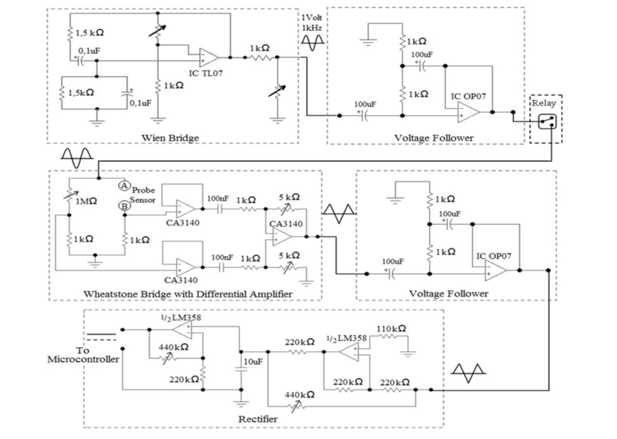

# PIN DIAGRAM CONFIGURATION:

1. **Current Source (+):** This pin is used to provide an electrical current to the solution being tested. It is often labeled as the positive (or "+" or "I") electrode. This pin is typically connected to the red or power wire.
2. **Voltage Measurement (-):** This pin is used to measure the voltage across the solution between the two electrodes. It is often labeled as the negative (or "-" or "V") electrode. This pin is typically connected to the black or ground wire.
3. **Reference Electrode (if applicable):** Some conductivity sensors, especially those used in more complex setups, may have a reference electrode. This electrode helps stabilize the measurement and is often separate from the current and voltage electrodes.
4. **Temperature Sensor (if applicable):** In some conductivity sensors, there may be an additional pin for a built-in temperature sensor or a separate temperature compensation probe. This is used to account for temperature variations that can affect conductivity measurements.
5. **Ground (if applicable):** Depending on the design and requirements, there might be a separate ground pin to ensure a stable reference point for measurements.

# 6.Optical Sensors:

Optical sensors can be used to detect the presence of water or to monitor the turbidity (cloudiness) of water, which can be an indicator of water quality.

# PIN DIAGRAM:

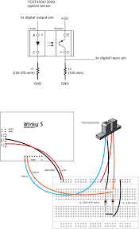

# PIN DIAGRAM CONFIGURATION:

1. VCC (Power Supply): This pin provides the voltage supply for the sensor. It typically requires a voltage within a specified range, such as 3.3V or 5V, depending on the sensor's design.
2. GND (Ground): The ground pin is connected to the common ground reference of the system.
3. Signal Output: This pin provides the output signal from the optical sensor. The type and format of the signal (analog or digital) can vary, depending on the sensor's design and intended use. You may also find additional pins for different output signals or modes (e.g., quadrature output in optical encoders).
4. LED Anode/Cathode (if applicable): Some optical sensors incorporate an LED for illumination. In such cases, there will be separate pins for the anode (+) and cathode (-) of the LED.
5. Shield/Case (if applicable): Some optical sensors may have a shield or case connected to a pin for grounding or shielding purposes to reduce electromagnetic interference.
6. Reference (REF) or Bias (if applicable): In some cases, optical sensors may include pins for reference voltage or biasing, particularly in more complex sensor designs.
7. No Connect (NC) or Unused Pins: Some sensor models may have pins that are not connected to anything or not used in a particular application. These pins are labeled as "NC."

# 7.Remote Sensing Technologies:

Satellite-based and aerial remote sensing technologies can provide data on water usage in large-scale agricultural, environmental, and industrial applications.

# PIN DIAGRAM:

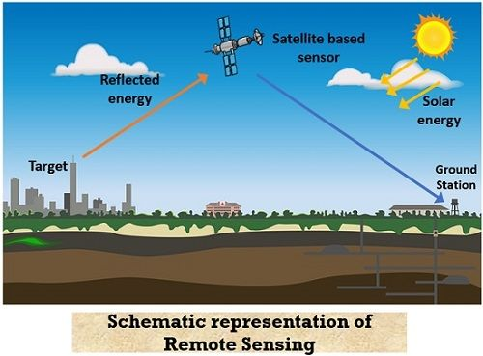

# PIN DIAGRAM CONFIGURATION:

1. **P-layer (P-type region)**: This is the first layer and is typically the top layer of the diode. It is doped with a material that has an excess of "holes" or positive charge carriers.
2. **Intrinsic layer (I-type region)**: The intrinsic region is a relatively thick, undoped layer in the middle. This layer allows for the absorption of photons and the creation of electron-hole pairs when light is incident upon the diode. It's important for the conversion of light signals into electrical signals.
3. **N-layer (N-type region)**: The N-layer is the bottom layer and is doped with a material that has an excess of electrons or negative charge carriers.

# 8.Water Quality Sensors:

While not strictly for measuring consumption, water quality sensors can monitor parameters such as pH, turbidity, temperature, and chemical composition, which can indirectly provide insights into water usage and the impact on water resources.

# PIN DIAGRAM:

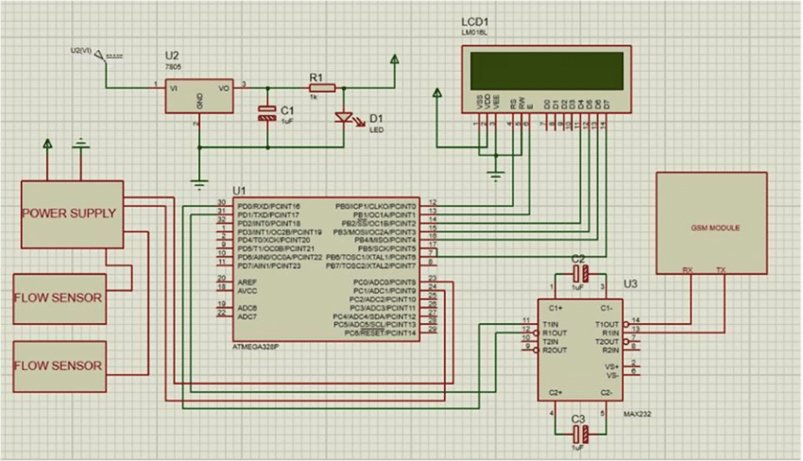

# PIN DIAGRAM CONFIGURATION:

1. **Probe**: This is the part of the sensor that comes into contact with the water to measure its properties. It typically includes electrodes for measuring various parameters like pH, conductivity, turbidity, or dissolved oxygen.
2. **Signal Output**: This is the part of the sensor that connects to your microcontroller or data logging device. It provides analog or digital signals that represent the measured water quality parameters.

The exact pin configuration can vary, but here's a general guideline:

**For a Water Quality Sensor with Analog Output**:

* VCC (Power): Connect this to a 5V or 3.3V power source on your microcontroller.
* GND (Ground): Connect this to the ground (0V) of your microcontroller.
* SIGNAL (Analog Output): This is the pin that provides the analog signal representing the measured parameter. Connect it to an analog input pin on your microcontroller.

**For a Water Quality Sensor with Digital Output**:

* VCC (Power): Connect this to a 5V or 3.3V power source on your microcontroller.
* GND (Ground): Connect this to the ground (0V) of your microcontroller.
* DATA (Digital Output): This is the pin that provides a digital signal (like a digital high or low) representing the measured parameter. Connect it to a digital input pin on your microcontroller.

# PROCEDURE:

1. **Assessment and Planning:**
   * Identify your water management goals, whether it's reducing water consumption, improving water quality, or ensuring a stable water supply.
   * Assess your current water infrastructure and practices to determine /areas that need improvement.
2. **Data Collection and Monitoring:**
   * Install sensors and meters to collect real-time data on water consumption, water quality, and system performance.
   * Implement a centralized data management system to gather and analyze data efficiently.
3. **Leak Detection and Prevention:**
   * Use water flow sensors and pressure sensors to detect leaks in the water distribution system.
   * Implement automated shutoff valves that can isolate sections of the network in case of leaks.
4. **Water Quality Monitoring:**
   * Employ sensors to continuously monitor water quality parameters such as pH, turbidity, and contaminants.
   * Set up alarms and notifications to respond promptly to water quality issues.
5. **Demand Management:**
   * Implement demand forecasting models to optimize water distribution and ensure a consistent supply.
   * Encourage water conservation and efficient water use practices among consumers.
6. **Smart Irrigation and Agriculture:**
   * Use weather data and soil moisture sensors to optimize irrigation schedules for agriculture and landscaping.
   * Utilize smart irrigation systems that adjust watering based on real-time conditions.
7. **Infrastructure Upgrades:**
   * Invest in modern infrastructure such as efficient pumps, pipes, and treatment facilities to reduce water losses and improve efficiency.
8. **Consumer Engagement:**
   * Educate and engage consumers on water conservation through apps, websites, and community programs.
   * Provide real-time consumption data to consumers to encourage responsible water use.
9. **Billing and Pricing:**
   * Implement water pricing mechanisms that reflect the actual cost of water provision and encourage conservation.
   * Use smart meters for accurate billing and to provide consumers with detailed consumption data.
10. **Emergency Response:**
    * Develop a robust emergency response plan for handling water supply disruptions, contamination events, and natural disasters.
    * Use data analytics to predict and mitigate potential issues.
11. **Regulatory Compliance:**
    * Ensure compliance with local, regional, and national water regulations.
    * Use data and reporting systems to provide necessary information to regulatory bodies.
12. **Remote Control and Automation:**
    * Enable remote control of water infrastructure, allowing for quick adjustments in response to changing conditions.
    * Automate routine tasks and maintenance activities to improve efficiency.
13. **Scalability and Integration:**
    * Ensure that your smart water management system is scalable to accommodate future growth.
    * Integrate with other smart city or utility systems for enhanced efficiency and coordination.
14. **Continuous Improvement:**
    * Regularly review and analyze data to identify areas for improvement.
    * Incorporate feedback from consumers and staff to refine the water management procedure.
15. **Training and Workforce Development:**
    * Train staff in the operation and maintenance of the smart water management system.
    * Keep your team up-to-date with emerging technologies and best practices.
16. **Public Awareness and Reporting:**
    * Communicate the benefits and progress of your smart water management efforts to the public.
    * Publish regular reports on water quality, consumption, and sustainability initiatives.

# ALGORITHM:

STEP 1: Data Collection and Sensing:

* Smart water management starts with the collection of real-time data from various sources such as sensors, weather stations, and remote monitoring systems. These sensors can measure parameters like water flow, water quality, temperature, humidity, and rainfall.

STEP 2: Data Analysis and Monitoring:

* Algorithms analyze the collected data to monitor the current state of water resources. This helps in identifying issues like leaks, over-usage, or pollution in the system.

STEP 3: Predictive Analytics:

* Smart algorithms can use historical data and machine learning techniques to make predictions about future water demand, quality, and potential issues. This can help water authorities and businesses plan for efficient water usage.

STEP 4: Demand Management:

* Algorithms can help balance supply and demand by adjusting water distribution in real-time based on demand patterns and forecasts. For example, they can optimize irrigation schedules for farmers or control water distribution in urban areas to minimize wastage.

STEP 5: Leak Detection:

* Smart water management algorithms can detect leaks in the distribution system by analyzing flow data. They can pinpoint the location of leaks and reduce water losses.

STEP 6: Water Quality Monitoring:

* Algorithms can continuously monitor water quality parameters and trigger alerts if contamination is detected. This is crucial for ensuring safe drinking water and maintaining water quality standards.

STEP 7: Infrastructure Maintenance:

* Algorithms can schedule maintenance for water infrastructure such as pipes, pumps, and treatment facilities based on predictive analytics. This proactive approach can reduce costly breakdowns and water loss.

STEP 8: Optimization of Water Treatment:

* Algorithms can optimize water treatment processes to ensure that the right treatment is applied to different water sources and conditions, saving energy and resources.

STEP 9: Water Resource Allocation:

* In agricultural contexts, smart water management algorithms can determine when and where to allocate water resources based on crop types, soil conditions, and weather forecasts to maximize yield and conserve water.

STEP 10: Remote Control and Automation:

* In some cases, algorithms can be integrated with control systems to automate valves, pumps, and other water management components, allowing for precise control and efficient operations.

STEP 11: Consumer Engagement:

* Smart water management systems can also engage consumers through mobile apps and online platforms, providing information on water consumption and tips on how to conserve water.

STEP 12: Reporting and Visualization:

* Data collected and analyzed by the algorithms can be presented to water authorities and users through user-friendly dashboards and reports, enabling data-driven decision-making.

STEP 13: Compliance and Regulation:

* These algorithms can help ensure that water management practices comply with environmental regulations and standard.

# PROGRAM:

import random

import time

class WaterLevelSensor:

def __init__(self, location):

self.location = location

def read_level(self):

# Simulate water level data (0-100%)

return random.uniform(0, 100)

class PumpController:

def __init__(self):

self.pump_status = False

def start_pump(self):

self.pump_status = True

print("Pump is turned ON.")

def stop_pump(self):

self.pump_status = False

print("Pump is turned OFF.")

def main():

sensor = WaterLevelSensor("Tank 1")

controller = PumpController()

while True:

water_level = sensor.read_level()

print(f"Water level in {sensor.location}: {water_level:.2f}%")

if water_level < 30:

controller.start_pump()

elif water_level > 70:

controller.stop_pump()

time.sleep(5) # Simulate reading the sensor every 5 seconds

if __name__ == "__main__":

main()